# Find In Demo Document

The quick brown fox jumps [1]over the lazy dog. The quick brown fox jumps over the lazy dog. The quick brown fox jumps over the lazy dog.[2]

The quick brown fox jumps over the lazy dog. The quick brown fox jumps over the lazy dog. The quick brown fox jumps over the lazy dog.

The quick brown fox jumps over the lazy dog. The quick brown fox jumps over the lazy dog. The quick brown fox jumps over the lazy dog.

Text in Textbox TxtTxt

# Chart

# SmartArt

# Find In options

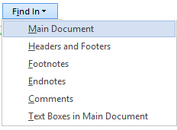

Enjoy.

1. Endnote Text
2. Footnote text